**SWOT Analysis - Definition, Advantages and Limitations**

**SWOT is an acronym for Strengths, Weaknesses, Opportunities and Threats**. By definition, Strengths (S) and Weaknesses (W) are considered to be internal factors over which you have some measure of control. Also, by definition, Opportunities (O) and Threats (T) are considered to be external factors over which you have essentially no control. It is designed to facilitate a realistic, fact-based, data-driven look at the strengths and weaknesses of an organization, initiatives, or within its industry. The organization needs to keep the analysis accurate by avoiding pre-conceived beliefs or gray areas and instead focusing on real-life contexts. Companies should use it as a guide and not necessarily as a prescription. Its key purpose is to identify the strategies that will create a firm specific business model that will best align an organization’s resources and capabilities to the requirements of the environment in which the firm operates.

An overview of the four factors (Strengths, Weaknesses, Opportunities and Threats) is given below-

1. **Strengths -** Strengths are the qualities that enable us to accomplish the organization’s mission. These are the basis on which continued success can be made and continued/sustained.

Strengths can be either tangible or intangible. These are what you are well-versed in or what you have expertise in, the traits and qualities your employees possess (individually and as a team) and the distinct features that give your organization its consistency.

Strengths are the beneficial aspects of the organization or the capabilities of an organization, which includes human competencies, process capabilities, financial resources, products and services, customer goodwill and brand loyalty. Examples of organizational strengths are huge financial resources, broad product line, no debt, committed employees, etc.

1. **Weaknesses -** Weaknesses are the qualities that prevent us from accomplishing our mission and achieving our full potential. These weaknesses deteriorate influences on the organizational success and growth. Weaknesses are the factors which do not meet the standards we feel they should meet.

Weaknesses in an organization may be depreciating machinery, insufficient research and development facilities, narrow product range, poor decision-making, etc. Weaknesses are controllable. They must be minimized and eliminated. For instance - to overcome obsolete machinery, new machinery can be purchased. Other examples of organizational weaknesses are huge debts, high employee turnover, complex decision making process, narrow product range, large wastage of raw materials, etc.

1. **Opportunities -** Opportunities are presented by the environment within which our organization operates. These arise when an organization can take benefit of conditions in its environment to plan and execute strategies that enable it to become more profitable. Organizations can gain competitive advantage by making use of opportunities.

Organization should be careful and recognize the opportunities and grasp them whenever they arise. Selecting the targets that will best serve the clients while getting desired results is a difficult task. Opportunities may arise from market, competition, industry/government and technology. Increasing demand for telecommunications accompanied by deregulation is a great opportunity for new firms to enter telecom sector and compete with existing firms for revenue.

1. **Threats -** Threats arise when conditions in external environment jeopardize the reliability and profitability of the organization’s business. They compound the vulnerability when they relate to the weaknesses. Threats are uncontrollable. When a threat comes, the stability and survival can be at stake. Examples of threats are - unrest among employees; ever changing technology; increasing competition leading to excess capacity, price wars and reducing industry profits; etc.

**How to do a SWOT analysis**

A SWOT analysis generally requires decision-makers to first specify the objective they hope to achieve for the business, organization, initiative or individual.

From there, the decision-makers list the strengths and weaknesses as well as opportunities and threats.

Various tools exist to guide decision-makers through the process, often using a series of questions under each of the four elements. For example, decision-makers may be guided through questions such as "What do you do better than anyone else?" and "What advantages do you have?" to identify strengths; they may be asked "Where do you need improvement?" to identify weaknesses. Similarly, they'd run through questions such as "What market trends could increase sales?" and "Where do your competitors have market advantages?" to identify opportunities and threats.

**Example of a SWOT analysis**

The end result of a SWOT analysis should be a chart or list of a subject's characteristics. The following is an example of the analysis of an imaginary retail employee:

Strengths: good communication skills, on time for shifts, handles customers well, gets along well with all departments, physical strength, good availability.

Weaknesses: takes lengthy smoke breaks, low technical skill, very prone to spending time chatting.

Opportunities: storefront worker, greeting customers and assisting them to find products, helping keep customers satisfied, assisting customers post-purchase with items and ensuring buying confidence, stocking shelves.

Threats: occasionally missing time during peak business due to breaks, sometimes too much time spent per customer post-sale, too much time in interdepartmental chat.

**Using a SWOT analysis**

A SWOT analysis should be used to help an entity, whether it is an organization or an individual, to gain insight into its current and future position in the marketplace or against a stated goal. The idea is that because entities can see competitive advantages, and positive prospects as well as existing and potential problems, they can develop plans to capitalize on positives and address deficiencies.

In other words, once the SWOT factors are identified, decision-makers should be better able to ascertain if an initiative, project or product is worth pursuing and what is needed to make it successful. As such, the analysis aims to help an organization match its resources to the competitive operational environment.

SWOT analysis pros and cons

SWOT analysis can help the decision-making process by creating a visual representation of the various factors that are most likely to impact whether the business, project, initiative or individual can successfully achieve an objective.

Although that snapshot is important for understanding the multiple dynamics that impact success, a SWOT analysis does have limits. The analysis may not include all relevant factors for all four elements, thereby giving a skewed perspective. In addition, because it only captures factors at a particular point in time and doesn't allow for how those factors could change over time, the insight SWOT offers can have a limited shelf life.

## Examples of a SWOT analysis

For illustration, here’s a brief SWOT example from a hypothetical, medium-sized computer store in the United States:

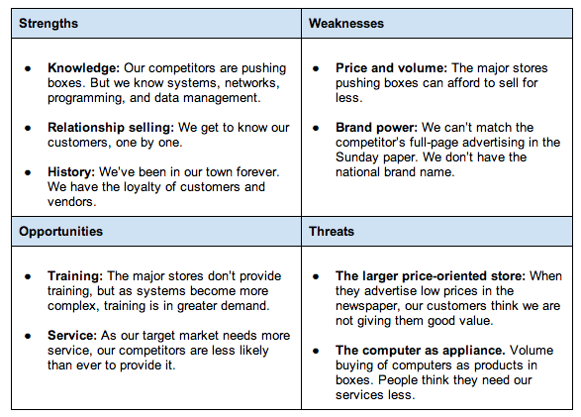

**What is a TOWS Analysis?**

A TOWS Analysis is an extension of the SWOT Analysis framework that identifies your Strengths, Weaknesses, Opportunities and Threats but then goes further in looking to match up the Strengths with Opportunities and the Threats with Weaknesses. It’s a great next step after completing your SWOT and allows for you to take action from the analysis**.**

## Similar to a SWOT, a TOWS analysis will involve the identification of an organisation’s strengths, weaknesses, opportunities and threats; however, often a key criticism of a SWOT analysis is that it doesn’t show the relationships between the different factors and categories. For example, a particular threat might make a weakness much more significant. Whereas a TOWS analysis will look to match internal factors to external factors to help identify relevant strategic options that an organisation could pursue. It can help an organisation to see how it can take advantage of opportunities, reduce threats, overcome weaknesses and exploit any strengths

## A TOWS is a commonly used strategic planning tool and can add real value to an organisation, helping to take strategic planning one step further. Below is an example TOWS matrix.

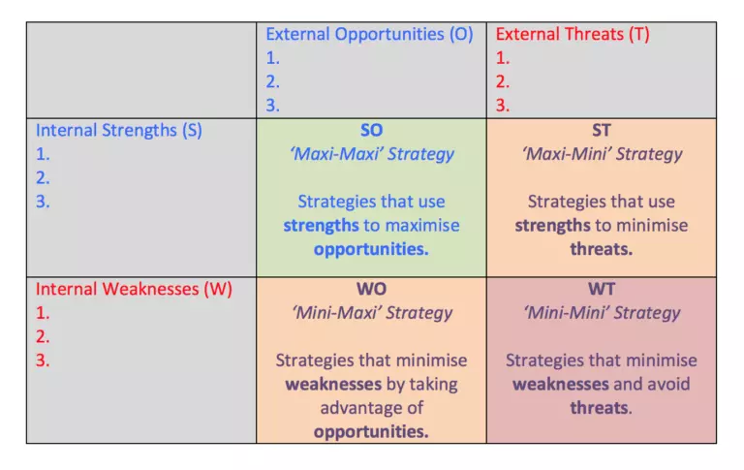

## TOWS analysis: Developing strategies from your SWOT analysis

Once you have identified and prioritized your SWOT results, you can use them to develop short-term and long-term strategies for your business. After all, the true value of this exercise is in using the results to maximize the positive influences on your business and minimize the negative ones.

But how do you turn your SWOT results into strategies? One way to do this is to consider how your company’s strengths, weaknesses, opportunities, and threats overlap with each other. This is sometimes called a **TOWS analysis.**

For example, look at the strengths you identified, and then come up with ways to use those strengths to maximize the opportunities (these are strength-opportunity strategies). Then, look at how those same strengths can be used to minimize the threats you identified (these are strength-threats strategies).

Continuing this process, use the opportunities you identified to develop strategies that will minimize the weaknesses (weakness-opportunity strategies) or avoid the threats (weakness-threats strategies).

The following table might help you organize the strategies in each area:

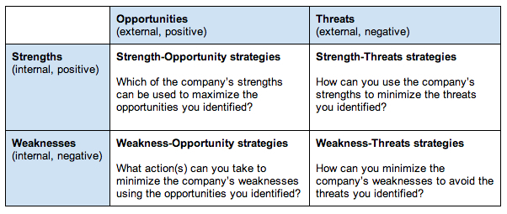

Once you’ve developed strategies and included them in your [strategic plan,](https://articles.bplans.com/strategic-plan-for-your-business/) be sure to schedule regular review meetings. Use these meetings to talk about why the results of your strategies are different from what you’d planned (because they always will be) and decide what your team will do going forward.